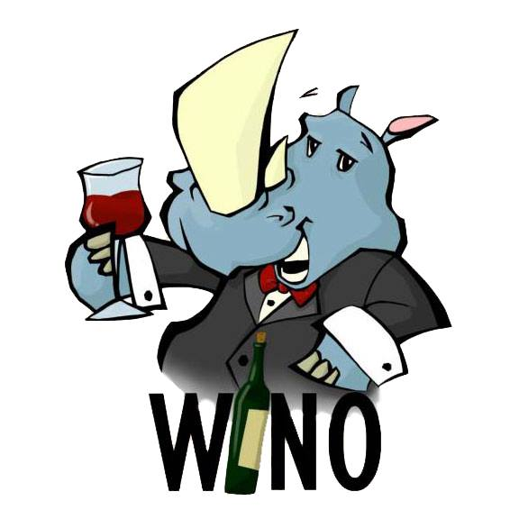

User Story

Acceptance Tests

**Table of Contents**

Notes

Terms

Logging In

Logging out

Tutorial: How to Taste Wine

Tutorial: Wine Accessories

Tutorial: Storing and Serving Wine

Tutorial: Wine Reviews

Add Wine to Vineyard

Delete Wine from Vineyard

Pairing Wine to Food

Pairing Food to Wine

Check Blood Alcohol Content (Male)

Check Blood Alcohol Content (Female)

Check Blood Alcohol Content (Error)

**Notes:**

1. <test user> refers to the person who is performing the tests.

2. If any backtracking is necessary, <test user> can press either the back button

on the device or by pressing the title bar on the screen (it will have a “<” symbol next to the title).

3. Each acceptance tests assumes that you start at the main screen of the application (the screen shown after logging in).

**Terms:**

1. **Vineyard**: The user’s personal inventory of wine that they currently own.

2. **Wish** **List**: The user’s list of wine that they want to own but do not currently

own it.

3. **Description**: A brief summary of what the feature that the acceptance test covers.

4. **Steps**: A sequence of instructions to perform the acceptance test.

5. **Expected Outcome**: A brief description of what the tester should see and

of what should happen after the last step is performed.

6. **Results**: A short summary describing the success/failure of the acceptance test and any notable details of why failure occurred or what the failure was (i.e. the app unexpectedly stop or the actual outcome didn’t match the expected outcome).

**Logging In**

**Description:**

All registered users should be able to log in with a valid email address and password.

**Steps:**

1. <test user> logs in with the email address and password that they created as specified in the “Registering A New Account” User Test Acceptance Story.

2. <test user> presses “Login”

**Expected Outcome:**

<test user> should be viewing the main screen (it has two buttons on the bottom of the screen: “Menu” on the left and “Quick Add” on the right).

**Results:**

**Logging Out**

**Description:**

All registered users should be able to log out of their account.

**Steps:**

1. <test user> logs in with their valid email address and password.

2. <test user> presses “Login”

3. After seeing the main screen (with the 2 buttons), <test user> presses “Menu”

4. <test user> presses “Logout”

**Expected Outcome:**

<test user> should be viewing the login screen upon a successful logout.

**Results:**

**Tutorial: How to Taste Wine**

**Description:**

All registered users should be able to view tutorials on how to taste/consume wine.

**Steps:**

1. From the login screen of the app, <test user> will log in with a valid email address and password.

2. <test user> presses “Menu”

3. <test user> presses “Help”

4. <test user> presses “Video Tutorials”

5. <test user> presses “Wine Tasting 101”

**Expected Outcome:**

<test user> is viewing resources (a website or a video) on how to taste/consume wine.

**Results:**

**Tutorial: Wine Accessories**

**Description:**

All registered users should be able to view tutorials on the different accessories that people can use to enjoy wine.

**Steps:**

1. From the login screen of the app, <test user> will log in with a valid email address and password.

2. <test user> presses “Menu”

3. <test user> presses “Help”

4. <test user> presses “Video Tutorials”

5. <test user> presses “Ideal Wine Gadgets”

**Expected Outcome:**

<test user> is viewing resources (a website or a video) on the different accessories that people can use to enjoy wine.

**Results:**

**Tutorial: Storing & Serving Wine**

**Description:**

All registered users should be able to view tutorials on how to store and serve wine

**Steps:**

1. From the login screen of the app, <test user> will log in with a valid email address and password.

2. <test user> presses “Menu”

3. <test user> presses “Help”

4. <test user> presses <something>

**Expected Outcome:**

<test user> is viewing resources (a website or a video) on how to store and serve different types of wine.

**Results:**

**Tutorial: Wine Reviews**

**Description:**

All registered users should be able to view other people’s reviews on wine that they may have drank or will want to drink in the near future.

**Steps:**

1. From the login screen of the app, <test user> will log in with a valid email address and password.

2. <test user> presses “Menu”

3. <test user> presses “Help”

4. <test user> presses “Wine Resources”

5. <test user> presses “Wine Reviews”

**Expected Outcome:**

<test user> is viewing a website where they can search for wines and read reviews about them

**Results:**

**Add Wine to Vineyard**

**Description:** All registered users should be able to add wine to their personal inventory.

**Steps:**

1. From the login screen, <test user> will login with a valid email address and password

2. <test user> presses “Menu”

3. <test user> presses “My Vineyard”

4. <test user> presses the plus sign button located at the top right of the screen

5. At the Wine name field, <test user> enters “Some Kind of Wine”

6. At the Winery field, <test user> enters “Somewhere over the rainbow”

7. At the Varietal field, <test user> enters “Oh, it’s Port”

8. At the Vintage field, <test user> selects the year “1998”

9. At the Quantity field, <test user> selects “12” and then selects “Cases”

8. At the rating bar, <test user> presses the left half of the 4th glass to represent

a 3.5/5 raiting.

9. At the location field, <test user> enters “In my secret box (the big one)”

10. At the comments field, <test user> enters “This wine smells like chocolate, but tastes like strawberries”

11. <test user> presses “Save”

**Expected Outcome:**

<test user> is viewing the main inventory screen. <test user> will scroll through the list and find the wine they just entered (in this case it’s “Some Merlot”).

**Results:**

**Deleting Wine from Vineyard**

**Description:**

All registered users should be able to delete wine from their personal inventory

**Steps:**

1. From the login screen, <test user> logs in with their valid email address and password

2. <test user> presses “Menu”

3. <test user> presses “My Vineyard”

4. <test user> presses and holds <the wine to be deleted>

5. <test user> notices the pop-up text box and presses “OK”

**Expected Outcome:**

<test user> should now be viewing their inventory and notice that the wine they selected to be deleted is now gone.

**Results:**

**Pairing Wine to Food**

**Description:**

All registered users should be able to pair a specific type of wine with a specific category of food.

**Steps:**

1. From the login screen, <test user> logs in with their email address and password

2. <test user> presses “Menu”

3. <test user> presses “Pair It”

4. <test user> presses “Pair a Wine!”

5. <test user> enters “Moscato” into the text field

6. <test user> presses “Bottega Petalo Moscato”

7. <test user> presses “Chicken Marsala with Pancetta & Cream”

**Expected Outcome:**

<test user> should be viewing a webpage of a recipe for “Chicken Marsala with Pancetta & Cream” where they will be able to rate it and read reviews about it if the user wishes to do so.

**Results:**

**Pairing Food to Wine**

**Description:**

All registered users should be able to pair a specific category of food with a specific varietal of wine.

**Steps:**

1. From the login screen, <test user> logs in with their email address and password

2. <test user> presses “Menu”

3. <test user> presses “Pair It”

4. <test user> presses “Pair a Meal!”

5. <test user> presses “Pizza/Pasta”

6. <test user> presses “Pasta”

7. <test user> presses “Marinara Sauce”

**Expected Outcome:**

<test user> should be viewing a result screen that has the wine varietal, Chianti, as the wine varietal that pairs well with the Pasta with Marinara Sauce. There is also a detailed description of the wine varietal and is left up to the user if they wish to pursue this pairing further.

**Results:**

**Checking Blood Alcohol Content (Male)**

**Description:**

All registered users should be able to check their own (or someone else’s) BAC.

**Steps:**

1. From the login screen, <test user> logs in with a valid email address and password

2. <test user> presses “Menu”

3. <test user> presses “BAC”

4. <test user> types in “170” for the Weight field.

5. <test user> types in “Male” for the Gender field.

6. <test user> types in “3” for the Number of Drinks field.

7. <test user> types in “2” for the Hours field.

8. <test user> types in “0” for the Minutes field.

9. <test user> presses “Use Breathalyzer”

**Expected Outcome:**

<test user> should see a Toast window pop up saying:

*Your BAC is: 0.06*

*You’re IMPAIRED*

*Time until sobriety: 4 hours and 40 minutes.*

**Results:**

**Checking Blood Alcohol Content (Female)**

**Description:**

All registered users should be able to check their own (or someone else’s) BAC.

**Steps:**

1. From the login screen, <test user> logs in with a valid email address and password

2. <test user> presses “Menu”

3. <test user> presses “BAC”

4. <test user> types in “135” for the Weight field.

5. <test user> types in “Female” for the Gender field.

6. <test user> types in “4” for the Number of Drinks field.

7. <test user> types in “1” for the Hours field.

8. <test user> types in “20” for the Minutes field.

9. <test user> presses “Use Breathalyzer”

**Expected Outcome:**

<test user> should see a Toast window pop up saying:

*Your BAC is: 0.17*

*You’re INTOXICATED*

*Time until sobriety: 11 hours and 20 minutes.*

**Results:**

**Checking Blood Alcohol Content (Error)**

**Description:**

All registered users should be able to check their own (or someone else’s) BAC.

**Steps:**

1. From the login screen, <test user> logs in with a valid email address and password

2. <test user> presses “Menu”

3. <test user> presses “BAC”

4. <test user> types in “Male” for the Gender field.

5. <test user> types in “4” for the Number of Drinks field.

6. <test user> types in “1” for the Hours field.

7. <test user> types in “0” for the Minutes field.

8. <test user> presses “Use Breathalyzer”

**Expected Outcome:**

<test user> should see a Toast window pop up saying:

Weight must be provided!

**Results:**